**NLP**

NLU NLG

NLU- Natural Language Understanding (NLU) is about enabling computers to understand the meaning of the text. If a human were to ask a computer a question, NLU attempts to understand the question

For example, if the user is asking about today's weather or the traffic conditions on a particular route- NLU understands the intent of question

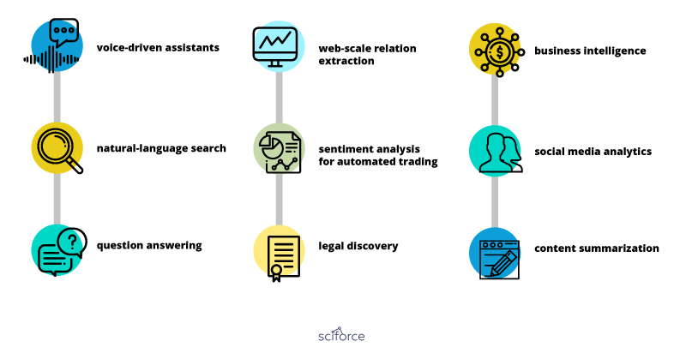

NLG- **Natural Language Generation (NLG)** is the process of generating descriptions or narratives in natural language from structured data

Gmail's Smart Compose. It reads email content and suggests short responses. The  NLG to generate thousands of corporate earnings reports in seconds

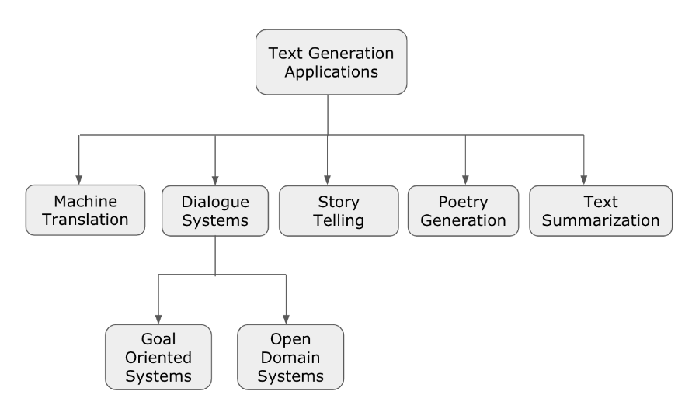



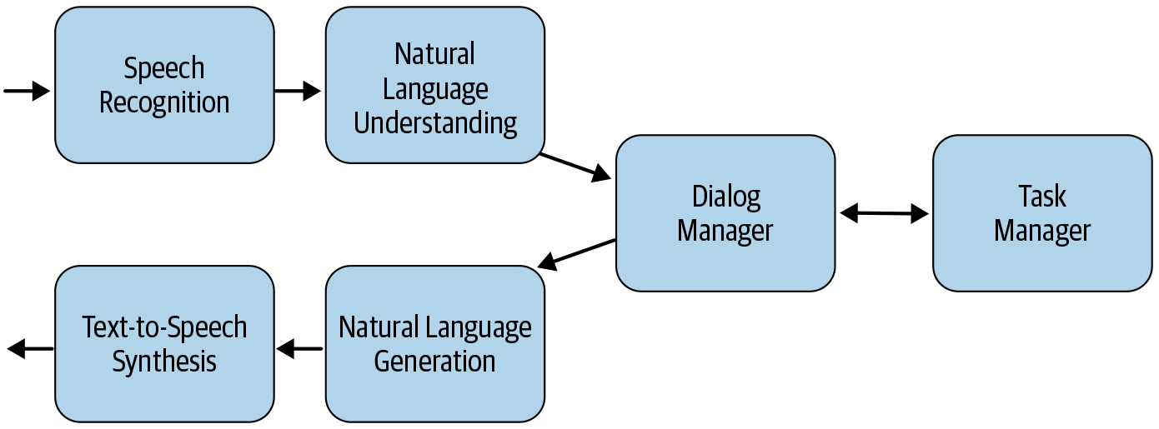

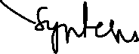

**NLU- Natural Language Understanding**

 Natural Language Understanding (NLU) is about enabling computers to understand the meaning of the text

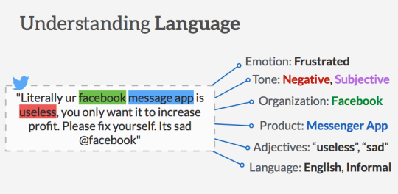

NLU attempts to understand the **semantic representation** of the input text

For example, if the user is asking about today's weather or the traffic conditions on a particular route, NLU helps in understanding the intent of the user's query

**Sentiment Analysis**: Understand if the text is expressing positive or negative sentiment. Emotion detection is a more granular form of sentiment analysis.



**Named Entity Recognition**: Identify and classify named entities (Person, Organization, Location, etc.) in the text.



Applications

* Chatbots or voice assistants
* Microsoft offers Language Understanding Intelligent Service (LUIS)
* IBM is Watson Assistant.
* Google, we have Dialogflow for voice and text-based conversational interfaces.



* Amazon Lex
* SAP Conversational AI
* Rasa NLU

**NLG- Natural language generation**

Natural Language Generation (NLG) is the process of generating descriptions or narratives in natural language from structured data





Gmail's Smart Compose. It reads email content and suggests short responses.

The Associated Press [**uses NLG**](https://www.marketingaiinstitute.com/blog/how-the-associated-press-and-the-orlando-magic-write-thousands-of-content-pieces-in-seconds?_ga=2.45476836.1302922534.1578923674-849186137.1573136992) to automatically create machine-written corporate earnings reports

OpenAI, a non-profit AI research company, announced they built an AI model that essentially [**writes coherent paragraphs of text at scale**](https://www.marketingaiinstitute.com/blog/what-happens-to-marketing-when-ai-can-write-like-humans). The model is called GPT-2 and it learned how to write this well by analyzing eight million web pages.

